
Conceptual Data Model (Enterprise ER Design)

1. Purpose of This Document
This document defines the Conceptual Data Model for Ubuntu National Bank’s Enterprise Data Platform. It provides a high-level, business-oriented view of the key entities and their relationships, independent of any specific database technology.
The objective is to:
- Validate business understanding
- Confirm entity boundaries
- Establish correct relationships and cardinality
- Identify weak (dependent) entities early
This model is reviewed and approved before logical and physical database design.

2. Core Design Principles
- Business-first modelling (not system-first)
- Clear separation of master, transactional, and historical data
- Explicit support for auditability and regulatory review
- Time-awareness for all critical state changes

3. Identified Entity Categories

3.1 Master Data Entities
- Customer
- Branch
- Employee
- Transaction Type

3.2 Transactional Entities
- Account
- Transaction
- Loan
- Loan Payment

3.3 Historical / Weak Entities
- Customer Address
- Account Status History
- Loan Repayment Schedule
- Audit Log

4. Entity Relationships & Cardinality

4.1 Customer ↔ Account
Relationship: Customer owns Account
- One Customer may have zero or many Accounts
- Each Account must belong to exactly one Customer
Cardinality:
- Customer (1) —— (0..M) Account
Justification:
Customers may exist historically without active accounts, but accounts cannot exist without a customer relationship.

4.2 Customer ↔ Customer Address
Relationship: Customer has Address
- One Customer may have one or many Addresses over time
- Each Address must belong to exactly one Customer
Cardinality:
- Customer (1) —— (1..M) Customer Address
Justification:
Addresses change over time and must be historised for compliance and verification.

4.3 Branch ↔ Account
Relationship: Branch manages Account
- One Branch may manage many Accounts
- Each Account must be managed by exactly one Branch
Cardinality:
- Branch (1) —— (0..M) Account
Justification:
Accounts are operationally tied to a single branch for reporting and accountability.

4.4 Account ↔ Account Status History
Relationship: Account has Status History
- One Account must have one or many Status History records
- Each Status History record belongs to exactly one Account
Cardinality:
- Account (1) —— (1..M) Account Status History
Justification:
Account status changes must be tracked historically to support dormant account analysis and audits.

4.5 Account ↔ Transaction
Relationship: Account records Transaction
- One Account may have zero or many Transactions
- Each Transaction must belong to exactly one Account
Cardinality:
- Account (1) —— (0..M) Transaction
Justification:
Transactions are immutable events that affect account balances and must be fully traceable.

4.6 Transaction ↔ Transaction Type
Relationship: Transaction is classified by Transaction Type
- One Transaction Type may classify many Transactions
- Each Transaction must reference exactly one Transaction Type
Cardinality:
- Transaction Type (1) —— (0..M) Transaction
Justification:
Standardised classification enables consistent reporting and regulatory compliance.

4.7 Customer ↔ Loan
Relationship: Customer holds Loan
- One Customer may have zero or many Loans
- Each Loan must belong to exactly one Customer
Cardinality:
- Customer (1) —— (0..M) Loan
Justification:
Loans represent credit exposure tied to an individual or organisation.

4.8 Loan ↔ Loan Repayment Schedule
Relationship: Loan has Repayment Schedule
- One Loan must have one or many Scheduled Repayments
- Each Schedule record must belong to exactly one Loan
Cardinality:
- Loan (1) —— (1..M) Loan Repayment Schedule
Justification:
Repayment schedules are generated at origination and define expected behaviour.

4.9 Loan ↔ Loan Payment
Relationship: Loan receives Payment
- One Loan may have zero or many Loan Payments
- Each Loan Payment must reference exactly one Loan
Cardinality:
- Loan (1) —— (0..M) Loan Payment
Justification:
Actual payments must be compared against scheduled repayments to detect delinquency.

4.10 Employee ↔ Account / Loan
Relationship: Employee services Account / Loan
- One Employee may service many Accounts or Loans
- An Account or Loan may be serviced by zero or many Employees over time
Cardinality:
- Employee (0..) —— (0..) Account / Loan
Justification:
Operational responsibility may change and must be historically traceable.

4.11 Audit Log ↔ All Core Entities
Relationship: Audit Log records changes to Core Entities
- One Audit Log entry must reference exactly one affected entity record
- Each Core Entity may have zero or many Audit Log entries
Cardinality:
- Core Entity (1) —— (0..M) Audit Log
Justification:
Auditability is mandatory for regulatory compliance and internal controls.
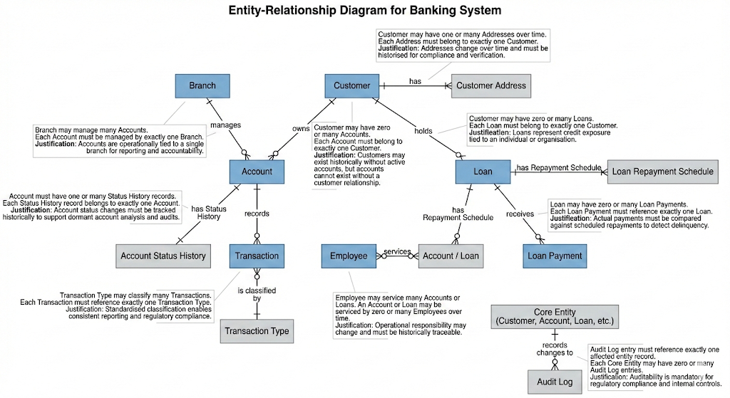

5. Identification of Weak Entities
The following entities are classified as weak entities and cannot exist independently:
- Customer Address (depends on Customer)
- Account Status History (depends on Account)
- Loan Repayment Schedule (depends on Loan)
- Loan Payment (depends on Loan)
- Audit Log (depends on Core Entities)
Their existence and identity are derived from their parent entities.

6. Conceptual Model Validation Checklist
The conceptual model supports:
- Customer-centric reporting
- Account and transaction reconciliation
- Historical state tracking
- Regulatory audit requirements
- Scalable analytical use cases
No business rules defined in Deliverables 1 and 2 are violated by this model.

7. Next Steps
- Translate conceptual entities into a logical data model
- Define attributes for each entity
- Identify primary and foreign keys
- Prepare for physical MySQL implementation

